Project management file
Project management file: initiation and project start
Project
Kind of project
Organisation
Project status
PM plan version
Prepared by
Last updated
Contents
To add page numbers in Word, right-click the list and choose Update Field.
Project at a glance
1 Process map: the ten steps
2 Core ideas and planning depth
Three views of a project
Four principles of the approach
The project management process
Planning effort
Triple constraint and planning depth
Method pyramid
3.1 Assess the idea
Business case
3.2 Categorise the project
3.3 Boundaries and context: the six fields
Time
Content
People
3.3 Project Charter
3.4 Stakeholder analysis
Steps 1 to 3: collect, group and assess
Steps 4 to 6: relation, measures, responsible and deadline
3.5 Scope: results plan and work breakdown structure
Three levels of scope
Results plan
Work breakdown structure
3.5 Schedule: milestones and bar chart
Milestones
Duration estimates
Dates
3.5 Resources and costs
Step 1: resource and cost types
Steps 2 and 3: depth and the plan per line
Step 4: staff placement and cost table
Step 5: availability
3.6 Project approval
4.1 Project organisation
Role descriptions
Organisational incorporation
4.1 Communication, culture and team development
Project culture
Team development
4.2 Who does what: RACI chart
4.2 Work package specifications
4.2 Detailed schedule: linked bar chart and network
Critical path
4.2 Detailed resources and costs: over time
Staff over time
Costs over time
Payments and gross margin
4.3 Consolidate and coordinate the detailed planning
Project marketing
4.4 Finalise the PM plan
4.5 Approve the PM plan
5 Risk management
Identify and assess
Risk budget and reserves
Risk controlling
6 Kick-off and start workshop
Kick-off meeting
Project start workshop
7 Contract management in customer projects
Contract analysis
8 Tailoring the planning process
Situation analysis
Method check
Planning navigator

Project at a glance
Your project file for the initiation and start of a project, from the first idea to the approved PM plan. Fill it in section by section; the graphics update as you type.
Method: How to use this workbook
- Start with the project details below. Name, dates and status feed the graphics on every page.
- Work through the sections in the menu in order. Section 1 shows the ten steps and where each one is documented.
- Grey text in a field or table is a hint from the template. Replace it with your own words.
- Switch on Example at the top to see a filled-in sample project. It is read-only, and your own file stays as it is.
- Your entries are saved as you type.
- Export makes a Word file with every table and graphic, and an Excel file with every table.

Project
Project name
Kind of project
Project status
Organisation
Prepared by
PM plan version
Last updated
Currency | €
Short description

Start and end
Start event
Start date
End event
End date
Duration

Project at a glance
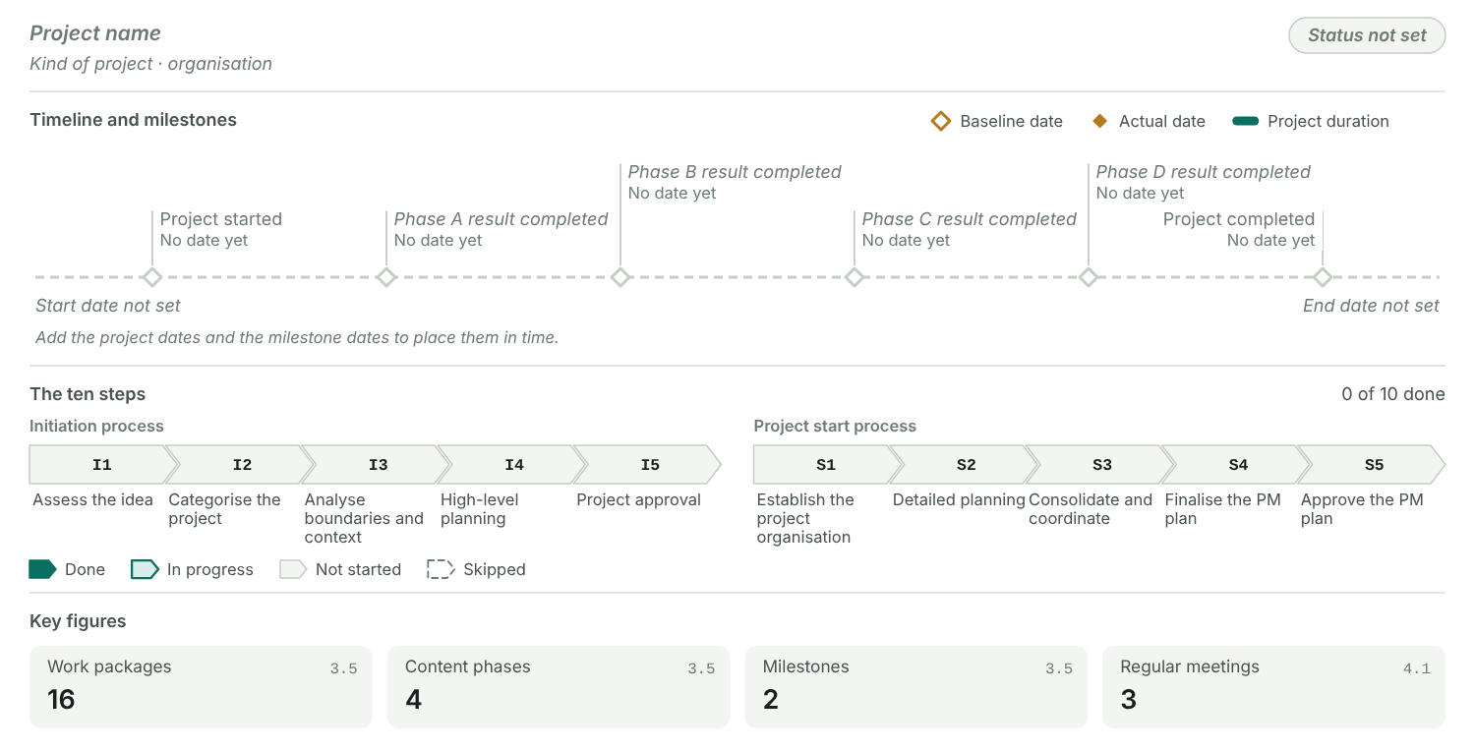
Figure 1: Project, timeline with the milestones, the status of the ten steps and the key figures of the plans. Hollow diamonds are baseline dates, filled ones actual dates.

Key figures
Figure | Value | From section
Project duration |  | At a glance
Steps done |  | 1 Process map
Business case (net) |  | 3.1 Assess the idea
Category |  | 3.2 Categorise the project
Objectives |  | 3.3 Six fields
Rough budget |  | 3.3 Six fields
Stakeholders |  | 3.4 Stakeholders
Critical stakeholders |  | 3.4 Stakeholders
Work packages | 16 | 3.5 Scope and WBS
Content phases | 4 | 3.5 Scope and WBS
Milestones | 2 | 3.5 Schedule
Planned cost |  | 3.5 Resources and costs
Person-days |  | 3.5 Resources and costs
Team size |  | 4.1 Project organisation
Regular meetings | 3 | 4.1 Communication and culture
Work packages with one R |  | 4.2 RACI chart
WP specifications agreed |  | 4.2 Work package specifications
Critical path |  | 4.2 Linked bar chart and network
Plans validated |  | 4.3 Consolidate and coordinate
PM plan version |  | 4.4 Finalise the PM plan
Project start process |  | 4.5 Approve the PM plan
Risk budget |  | 5 Risk management
High risks |  | 5 Risk management
Communication formats used |  | 6 Kick-off and start workshop
Accepted change requests |  | 7 Contract management
Critical situation answers |  | 8 Tailoring
Methods used |  | 8 Tailoring

Glossary
Term | Meaning | What we call it in our organisation
PO, PS | Project owner or project sponsor: two names for the same role. Strategic responsibility; represents the company in the project.
PM | Project manager. Full operative responsibility; a project has exactly one.
PMTM, PTM | Project management team member: a core team member who is responsible for work packages.
PSC | Steering committee above the project.
PMO | Project management office.
Project Charter | The project assignment, signed by PO and PM.
PM plan, PHB | All project plans and documents in one place, also called the project handbook.
WBS | Work breakdown structure: every task of the project, ordered by phase.
WP | Work package: a task in the WBS with one responsible person.
WBS code | Code of a WBS line, also called code of account (CoA), for example 1.3.3.
PD | Person-days (also written MD or PT).
BC | Business case: costs against benefits over the life cycle.
CR | Change request: a formal request to change scope, dates or costs.

1 Process map: the ten steps
Two processes of five steps each take a project from the first idea to an approved PM plan. Record for each step what happened in your project.
Method: What goes in and what comes out
- Initiation process (steps I1 to I5): starts with a project idea and ends with the (preliminarily) released Project Charter.
- Project start process (steps S1 to S5): starts with the preliminary charter and ends with the final charter and the approved PM plan, version 1.0.
- Each process ends with a decision of the PO: project approval in I5 and approval of the PM plan in S5.
- The ten steps are an example. Section 8 shows how to scale them to your project.

Process map
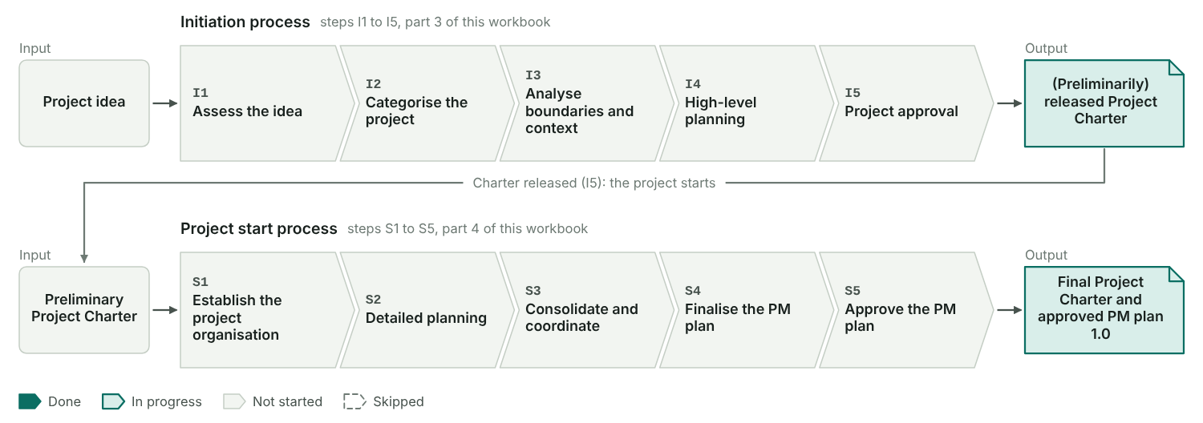
Figure 2: Each chevron is one step, coloured by its status in the table below, with the date you entered. The released charter at the end of the initiation is the input of the project start.

The ten steps in your project
Step | Step | Status | When | Format used | Who took part | What we did | Result
I1 | Assess the idea
I2 | Categorise the project
I3 | Analyse boundaries and context
I4 | High-level planning
I5 | Project approval
S1 | Establish the project organisation
S2 | Detailed planning
S3 | Consolidate and coordinate
S4 | Finalise the PM plan
S5 | Approve the PM plan

Initiation process: activities, roles, formats, results
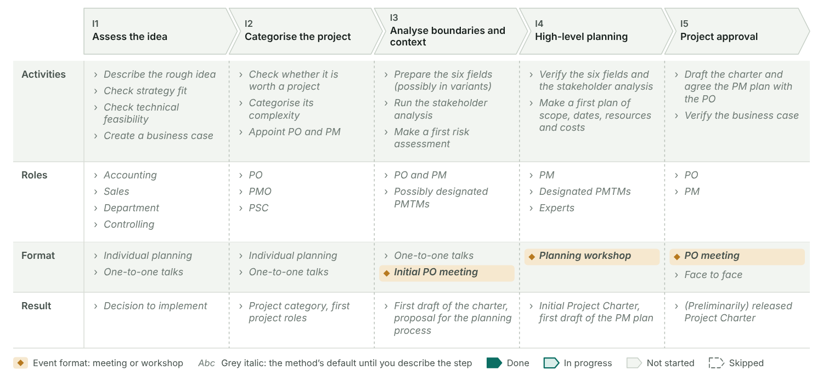
Figure 3: One column per step. Each cell shows what you wrote in the table above; until then it shows the method’s default in grey italics. Amber marks the formats that are events, the meetings and workshops.

Project start process: activities, roles, formats, results
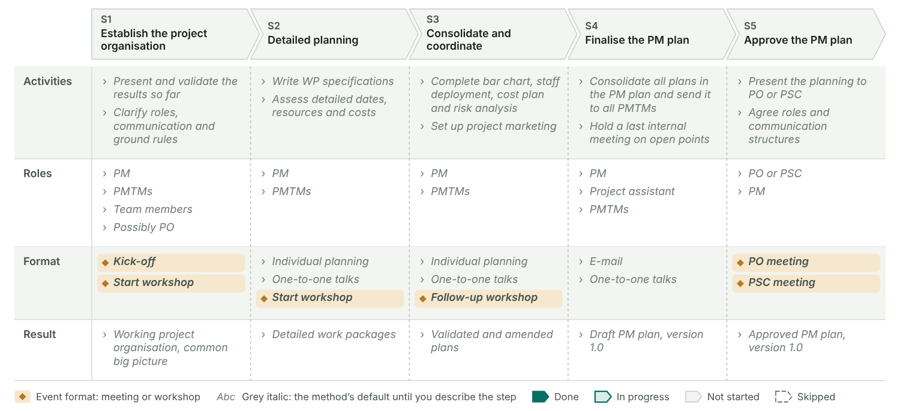
Figure 4: One column per step. Each cell shows what you wrote in the table above; until then it shows the method’s default in grey italics. Amber marks the formats that are events, the meetings and workshops.

2 Core ideas and planning depth
The ideas behind the method and how deep your planning goes. Note how each one applies to your project.

Three views of a project
A project is a task, a temporary organisation and a social system at the same time. Each view asks something different of the planning.
Task with special characteristics
Temporary organisation
Social system

Four principles of the approach
The method rests on four principles. Describe how you applied each one.

Principles in practice
 | Principle | In practice | How we applied it
M | Management process | Project management applies methods, tools, techniques and competencies to the project.
I | Iterative, process-oriented | Work in cycles of observing, deciding and acting. Plans are adapted step by step.
S | Systemic-constructivist | There is more than one reality, so the team has to build a common view.
T | Team-oriented | Project management is shared work: the whole team plans and controls.

The project management process
Every stage ends with a document. This workbook covers the first two stages.

Project management process
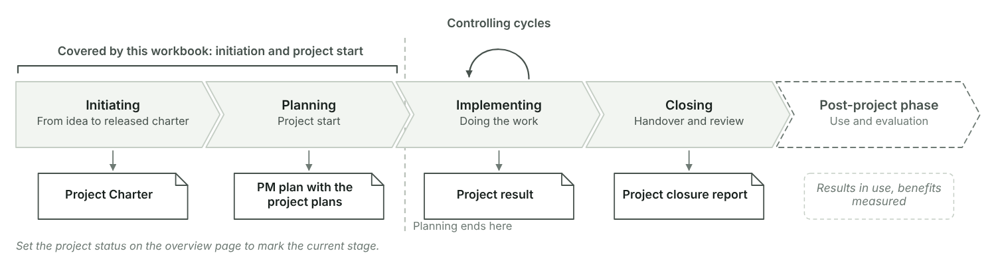
Figure 5: Initiating and planning are covered here; controlling runs in cycles during the implementation. The stage that matches the project status on the overview page is highlighted.

Planning effort
The more complex the task, the more planning it needs. Processes and line tasks stay in the line; projects and programmes get a temporary organisation.

Planning effort ladder
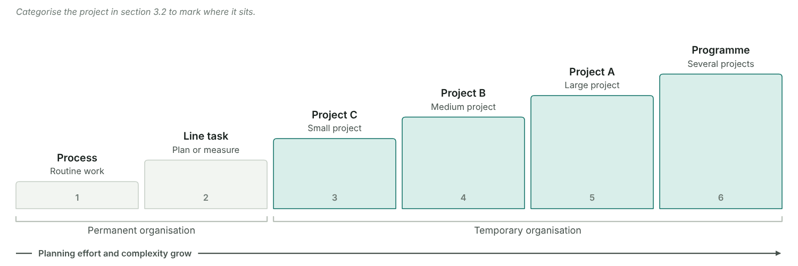
Figure 6: From routine process to programme, each step needs more planning. The marker shows the category set in section 3.2 (project class C, B or A).
The marker comes from the categorisation in section 3.2.

Triple constraint and planning depth
Scope, time, and resources and costs each get a plan. How deep each plan goes depends on the project, but no corner may be skipped.

How deep we plan
Scope plan
Schedule
Resource and cost plan

Triple constraint
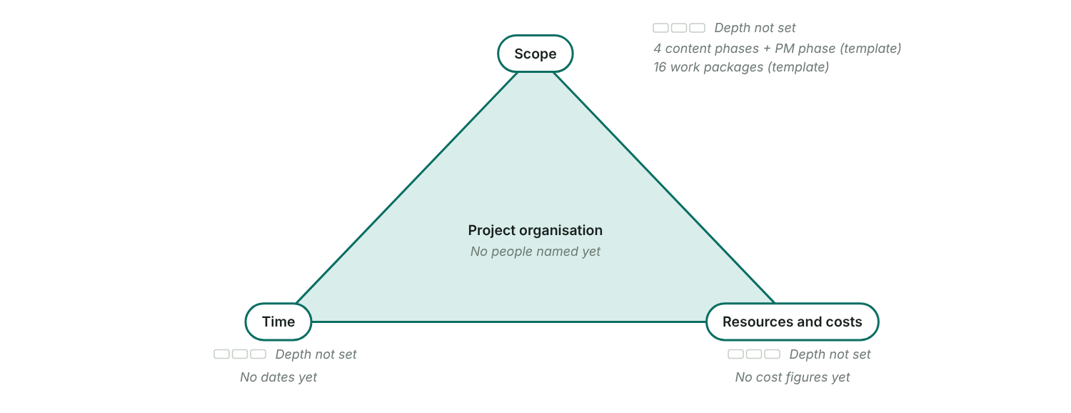
Figure 7: The project organisation sits in the middle and holds the three plans together. Each corner shows the chosen planning depth and this project’s figures.

Method pyramid
The more complex the project, the further up the pyramid the planning goes. Risk management grows with it.

Method pyramid
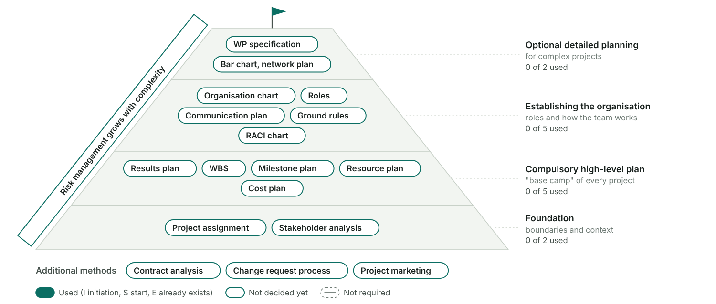
Figure 8: Methods by level, from the foundation to optional detailed planning, styled by the decisions in the method check.
Decide in the method check of section 8 which methods this project uses.

3.1 Assess the idea
Before anyone plans, check whether the idea fits the strategy, can be done and pays off. The result is a recorded decision.
Method: How to assess an idea
- Describe the idea in a few sentences: what it is, who proposed it and why now.
- Strategy fit: check that it serves the company strategy and makes the project portfolio better as a whole.
- Technical feasibility: check that the objectives are manageable, decide whether it is a concept or an implementation project, and whether a feasibility study must come first.
- Economic viability: set costs against benefits over the whole life cycle, name the uncertainties and compare the alternatives, including doing nothing.
- Close with a recorded decision: implement, reject, postpone or study feasibility first.

Step record I1: Assess the idea
Status
When
Format used
Who took part
What we did
Result

The idea
Rough idea
Proposed by
Proposed on
Type of project
Feasibility study

Three checks
Check | Question | Answer | Assessment
A. Strategy fit | Does the project close a gap between our objectives and the company strategy?
A. Strategy fit | Does it make our project portfolio better as a whole?
B. Technical feasibility | Are the objectives manageable with our skills, tools and capacity?
B. Technical feasibility | Is it clear whether this is a concept project or an implementation project?
B. Technical feasibility | Can we plan it without a feasibility study first?
C. Economic viability | Do the benefits outweigh the costs over the whole life cycle (business case)?
C. Economic viability | Are the uncertainties in costs and benefits known and acceptable?
C. Economic viability | Is this the best of the alternatives we compared, including doing nothing?

Business case
Costs and benefits over the whole life cycle, by year or period

Costs and benefits
No. | Item | Type | Nature | Year or period | Amount (€) | Note
1 |  | Cost | One-off
2 |  | Cost | One-off
3 |  | Cost | Recurring
4 |  | Benefit | Recurring
5 |  | Benefit | One-off
 | Total |  |  |  | Cost € 0 / Benefit € 0

Result
Total cost
Total benefit
Net benefit
Benefit / cost ratio

Alternatives compared
No. | Alternative | Description | Cost (€) | Benefit | Risk | Decision
1
2
3

Decision
Decision
Decided by
Decided on
Conditions and next steps

Idea assessment
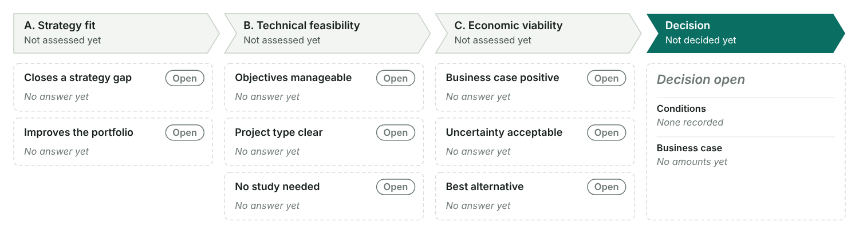
Figure 9: Each card is one question of the three checks, coloured by its assessment. The last column shows the decision they led to.

3.2 Categorise the project
Decide whether the idea is worth a project and how big it is. Then appoint the project owner and the project manager.
Method: How to categorise
- Check whether the task is worth a project at all. Small tasks run better in the line organisation.
- Compare the project with your company’s thresholds for divisions involved, duration, internal effort and external spend.
- Take the category most criteria reach, then confirm it or overrule it with a reason.
- Give it a size class if your company uses them: C small, B medium, A large.
- Appoint the project owner and the project manager, and name the first core team members if you can.

Step record I2: Categorise the project
Status
When
Format used
Who took part
What we did
Result
Every company sets its own limits. The grey numbers are one company’s example; type your own values over them.

Category criteria
Criterion | Unit | Rule | Plan or measure | Project | Programme | Our project | Reaches
Divisions involved | Divisions | at least
Duration | Months | at least
Internal effort | Person-days | more than
External spend | Money (€) | more than

Category
Suggested category
Final category
Size class
Worth a project?
Reason

Where the project sits
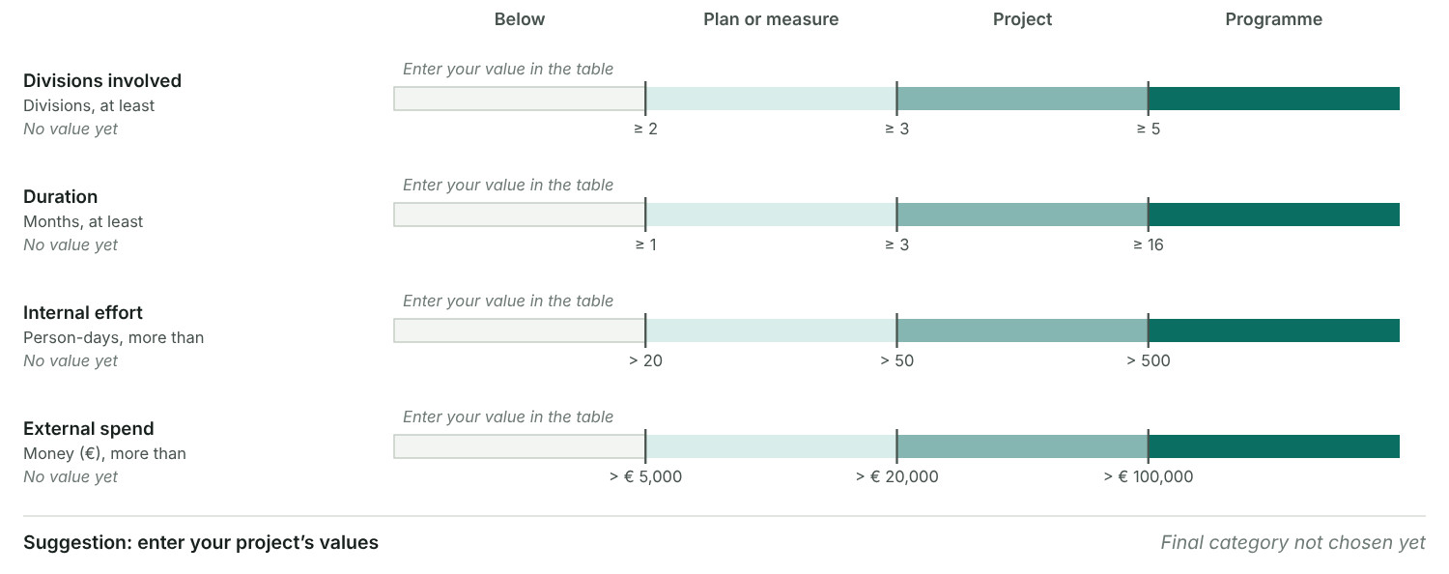
Figure 10: One scale per criterion. Each band runs from one threshold to the next and has the same width, so small and large numbers read alike. The dot is your project.

First project roles
No. | Role | Person | Appointed on | Appointed by | Note
1 | Project owner
2 | Project manager
From here on the project manager steers the process, usually with a vague brief, a preliminary status and a team that still has to be put together.

3.3 Boundaries and context: the six fields
Mark out what belongs to the project and look at what surrounds it, for time, content and people. The result is the first draft of the Project Charter.

Step record I3: Analyse boundaries and context
Status
When
Format used
Who took part
What we did
Result
Method: Why boundaries and context
- Only what is clearly defined can be planned, controlled and measured.
- Boundaries are the inside view: what belongs to the project and what does not. They become the Project Charter.
- Context is the outside view: what came before, what comes after, what runs alongside and who is affected. Knowing it is the basis for acceptance.
- Look at both for time, content and people. That gives six fields, the foundation for high-level and detailed planning.
- PO and PM fill them in together, in variants if the scope is still open. The same step covers the stakeholder analysis (3.4) and a first risk assessment (5).

The six fields
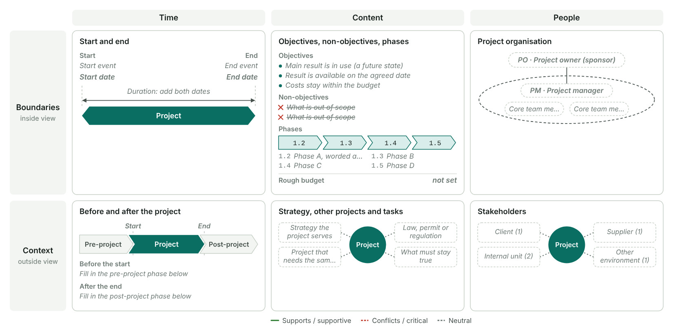
Figure 11: A one-page summary of this section. The top row is the boundary of the project, the bottom row its context. Edges in the context fields show whether a factor or a stakeholder group supports the project or conflicts with it.

Time
Fix start and end as an event and as a date. The event stays when the date moves.

Time boundaries
Start event
End event
Start date
End date
Duration

Pre-project phase: the history
What happened before the start
Decisions already taken
Documents that exist
Who supported the project
Who held it back

Post-project phase: the consequences
What happens with the results
Decisions and follow-up projects
Further benefits
What we organise during the project for this phase

Pre-project phase, project, post-project phase
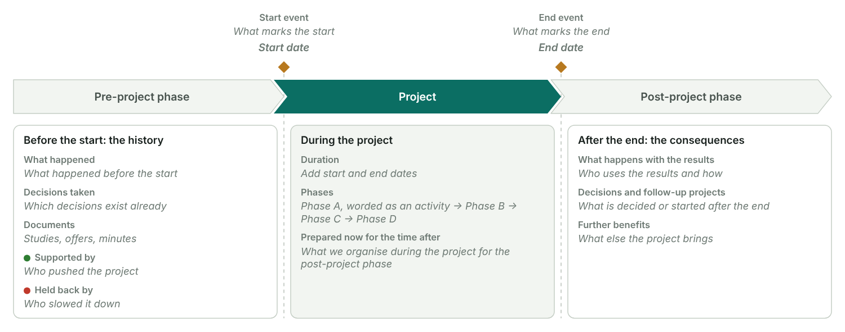
Figure 12: The start and end events (amber) mark the time boundary. Left: what led to the project. Right: what follows from it. The middle card lists what the project prepares now for the time after.

Content
Objectives, non-objectives, phases and a rough budget, and the factors around the project.

Top objective and rough budget
Top objective
Rough budget
What the budget covers

Objectives
No. | Objective | Class | Sub-class | Indicator | Target value | Priority
1 |  | Scope or functional
2 |  | Schedule
3 |  | Budget

Objective pyramid
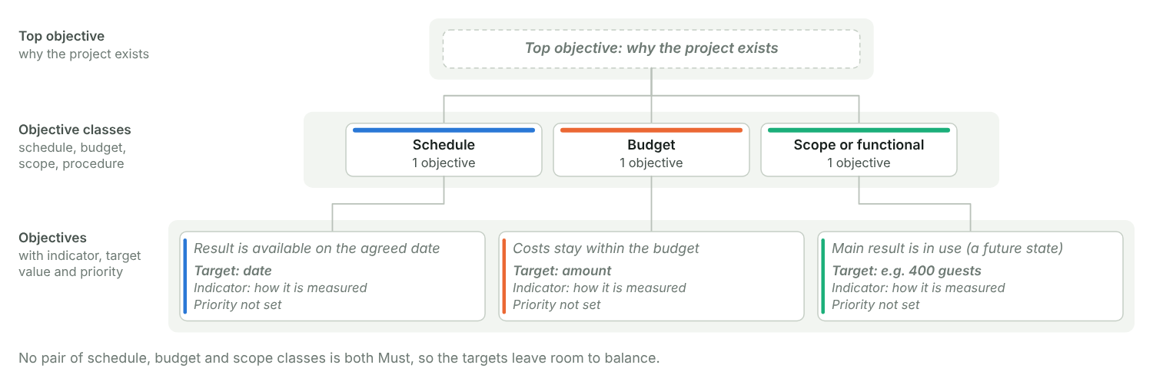
Figure 13: From the top objective through the objective classes to the measurable objectives. A red outline and "!" mark classes that pull against each other: when schedule, budget or scope both carry a Must objective, decide early which one gives way.

Non-objectives
No. | Non-objective | Why it is out
1
2

Phases
WBS | Phase | Main result of the phase | Rough start | Rough end
1.1 | Project management
1.2 | Phase A, worded as an activity
1.3 | Phase B
1.4 | Phase C
1.5 | Phase D
Method: Typical phase models
Phases can be standardised per type of project. Use these as a starting point and keep 4 to 5 phases.
- Construction or investment: engineering → approval by the authorities → procurement → construction and assembly → start-up → training → handover.
- Organisational development: analysis → target concept → pilot phase → roll-out of the full concept → training → introduction.
- Product development: market and internal analysis → feasibility study → development → testing and approval → pilot run → market launch.
- Software development: pre-study → functional concept → IT concept → build → test → training → introduction.

Context: strategy, other projects and outside factors
No. | Factor | Type | Effect | Information and coordination | Contact or shared role
1 |  | Company strategy
2 |  | Similar or parallel project
3 |  | Legal
4 |  | Assumption or critical parameter

Context of the project
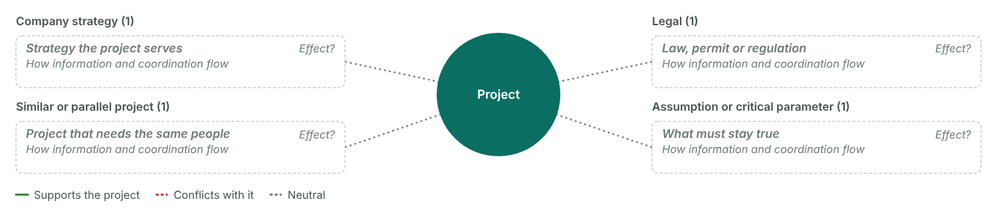
Figure 14: The project in the centre and the factors around it, grouped by type. Green solid edges support the project, red dashed edges conflict with it, grey dotted edges are neutral.

People
Who is inside the project: the project organisation.

Project organisation
No. | Name | Short | Project roles | Department / company | Sub-team | Contact
1 |  |  | Project owner
2 |  |  | Project manager
3 |  |  | PMTM
4 |  |  | PMTM

Project organisation (boundary)
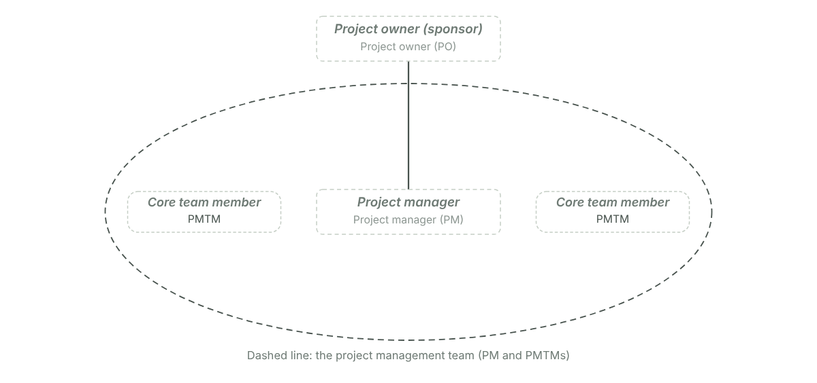
Figure 15: The project owner on top, the project manager below, and the core team (PMTM) around the PM. The dashed line is the boundary of the project management team.
The people context, everyone outside the project who is affected by it and may try to influence it, is the stakeholder analysis in 3.4.
A project that is defined too narrowly misses what it depends on, and vague boundaries invite scope creep. Agree a joint big project picture with the PO and the core team.

3.3 Project Charter
The formal assignment of the project: what it must achieve, by when, with which resources and with whom. PO and PM sign it.
PO, PM and the core team develop it together. It goes to the whole project organisation and to selected stakeholders. The signed version is part of the PM plan.

Charter
Status
Version
Date
Start event
Start date
Duration
End event
End date
Business need

Roles
Project sponsor (PO)
Project manager
Project core team
Project team members

Objectives
No. | Objective | Class | Sub-class | Indicator | Target value | Priority
1 |  | Scope or functional
2 |  | Schedule
3 |  | Budget

Non-objectives
No. | Non-objective | Why it is out
1
2

Main deliverables
No. | Main deliverable | Description | Due
1
2
3

Non-deliverables
No. | Non-deliverable | Note
1
2

Project phases
WBS | Phase | Main result of the phase | Rough start | Rough end
1.1 | Project management
1.2 | Phase A, worded as an activity
1.3 | Phase B
1.4 | Phase C
1.5 | Phase D

Resources and costs
No. | Type | What | Quantity | Unit | Cost per unit (€) | Cost (€)
1 | Staff (internal) |  |  | PD
2 | External labour
3 | Material or investment
 | Total |  |  |  |  | € 0

Signatures
Role | Name | Place | Date | Signed
Project owner (sponsor)
Project manager

Distribution
No. | Received by | Role | Date
1 |  | Project organisation
2 |  | Stakeholder

Project Charter on one page
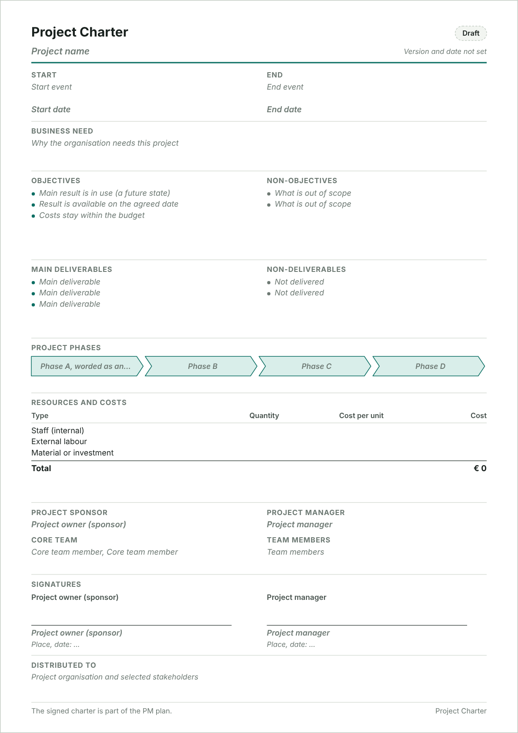
Figure 16: An A4 page in the classic charter layout, ready to print and sign. Long lists are cut with a "+ n more" note; the full lists are in the tables above. Phases leave out project management (1.1).

Charter checks
✗ Give the start both an event and a date.
✗ Give the end both an event and a date.
✗ List at least one objective.
✗ List at least one non-objective: it makes the objectives clearer.
✗ Name the project owner (sponsor).
✗ Name the project manager.
• No one has the role Project manager in the people list yet.
✗ Signature not complete (name, date, signed): Project owner (sponsor), Project manager.

3.4 Stakeholder analysis
Find everyone who is affected by the project or can influence it, judge where action is needed, and agree a measure, an owner and a deadline for each.
A good result still fails when the people around the project reject it. Stakeholder management means managing expectations: know who is affected and who has influence, plan what you do for each group, and build the understanding that prevents conflict. It is also the base for project marketing.
Method: The six steps
- Collect everyone who is affected by the project or holds an opinion about it. Inside: owner, manager, team. Outside: client, management, works council, suppliers, authorities, press, competitors. Start from the people context of the six fields. (Stakeholder table)
- Sort them into groups and draw them around the project in the stakeholder chart. (Stakeholder table, column Group)
- Rate how strongly each one is affected and how much influence they have, and mark them supportive, neutral or critical. The need for action follows from that. (Stakeholder table)
- For each one that needs attention, describe the relation: what each side expects, what they can offer, where conflicts lie. (Measures table)
- Derive a strategy and concrete measures, linked to a work package where one fits. (Measures table)
- Give every measure one responsible person and a deadline, and track its status. (Measures table)

The six steps in this file
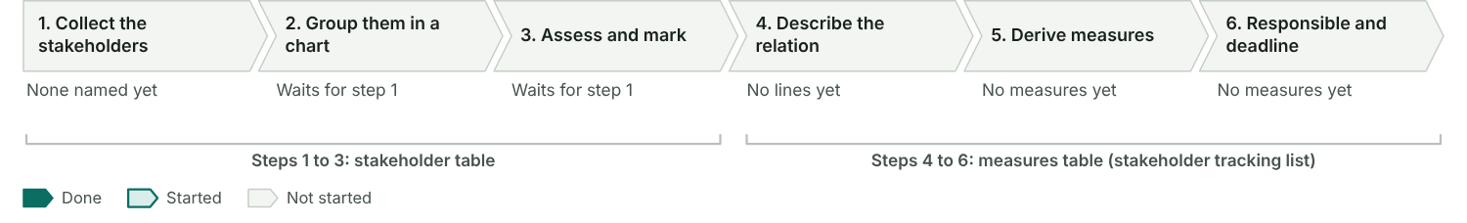
Figure 17: How far each step is filled in. Steps 1 to 3 live in the stakeholder table, steps 4 to 6 in the measures table.

Steps 1 to 3: collect, group and assess

Stakeholder table
No. | Stakeholder | Group | Internal / external | How affected | Influence | Attitude | Need for action | Expectations
1 |  | Client
2 |  | Internal unit | Internal
3 |  | Internal unit | Internal
4 |  | Supplier | External
5 |  | Other environment | External

Stakeholder chart
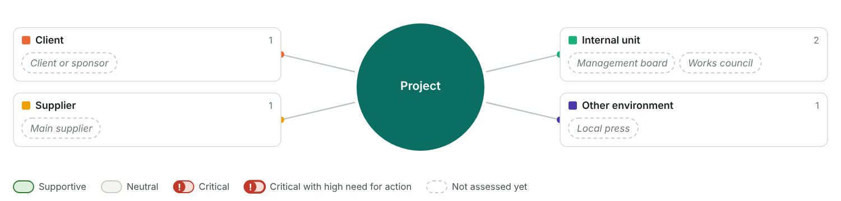
Figure 18: Step 2 and 3: the project in the centre, the stakeholders grouped around it. A red "!" marks critical stakeholders; a thick outline means a high need for action.

Influence and affectedness
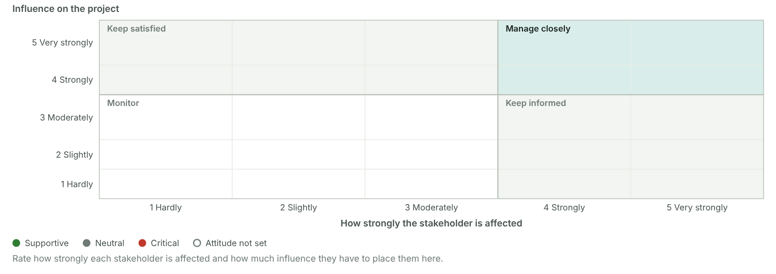
Figure 19: Step 3: each stakeholder placed by how strongly they are affected and how much influence they have. Those in the top right need the closest attention, especially when critical.

Steps 4 to 6: relation, measures, responsible and deadline

Measures table (stakeholder tracking list)
No. | Stakeholder | Relation | Description of relation | Measure | WBS | Responsible | Deadline | Status
1
2
3

Checks
• No stakeholder has a high need for action yet.
• No measures yet.

3.5 Scope: results plan and work breakdown structure
Scope planning works on three levels: why the project exists, what it delivers and what has to be done. List the results first, then build the work breakdown structure from them.

Step record I4: High-level planning
Status
When
Format used
Who took part
What we did
Result
Method: Scope planning in five steps
Steps 1 to 3 happen in the planning workshop. Steps 4 and 5 follow in detailed planning.
- List the results. Ask what has to exist at the end of the project, tangible or intangible, and break the overall result into partial results.
- Check the phases against the content boundaries from 3.3 (objectives, exclusions, phases) and put them in process order.
- Define the work packages within each phase, so that every result comes out of a work package.
- Give every work package one responsible person.
- Write a specification for each work package (see 4.2).

Three levels of scope
Each level answers its own question and ends up in its own document.

Scope levels
Level | Guiding question | Document | In our project
1 Objective | Why, and what has to be made possible for whom? | Project Charter, scope statement
2 Deliverables (interim and final results) | What is supplied? What do we have to think of? | Results plan
3 Process (tasks) | What has to be done? | Work breakdown structure, WP specifications

Scope statement and approach
Scope statement
Planning approach
Wording of work packages
Template WBS used

Results plan
What has to exist at the end of the project, broken down from the overall result.
The results plan is the best completeness check for the WBS: every result needs a work package that produces it.

Results plan
No. | Result | Part of | Type | Description | Produced by
1
2 |  | Overall result
3 |  | Overall result
4 |  | Overall result
5 |  | Main result 1
6 |  | Main result 1

Results plan
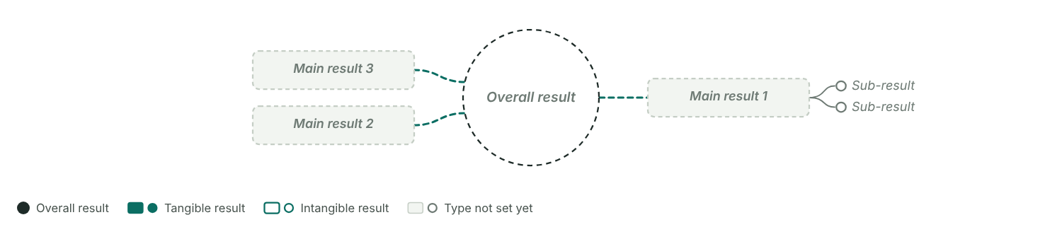
Figure 20: The overall result sits in the centre, main results around it, sub-results branch off them. Filled boxes and dots are tangible results (documents, objects); outlined ones are intangible (services, decisions, knowledge). Set the parent in the "Part of" column.

Work breakdown structure
All the work of the project, by phase. Code 1 is the project, 1.1 is project management, 1.2 onwards are the content phases.

Work breakdown structure
WBS code | Name | Responsible | Result / deliverable | Type
1 |  |  |  | Project
1.1 | Project management |  |  | PM phase
1.1.1 | Starting the project |  |  | Work package
1.1.2 | Coordinating the project |  |  | Work package
1.1.3 | Controlling the project |  |  | Work package
1.1.4 | Closing the project |  |  | Work package
1.2 |  |  |  | Phase
1.2.1 |  |  |  | Work package
1.2.2 |  |  |  | Work package
1.2.3 |  |  |  | Work package
1.3 |  |  |  | Phase
1.3.1 |  |  |  | Work package
1.3.2 |  |  |  | Work package
1.3.3 |  |  |  | Work package
1.4 |  |  |  | Phase
1.4.1 |  |  |  | Work package
1.4.2 |  |  |  | Work package
1.4.3 |  |  |  | Work package
1.5 |  |  |  | Phase
1.5.1 |  |  |  | Work package
1.5.2 |  |  |  | Work package
1.5.3 |  |  |  | Work package

Work breakdown structure
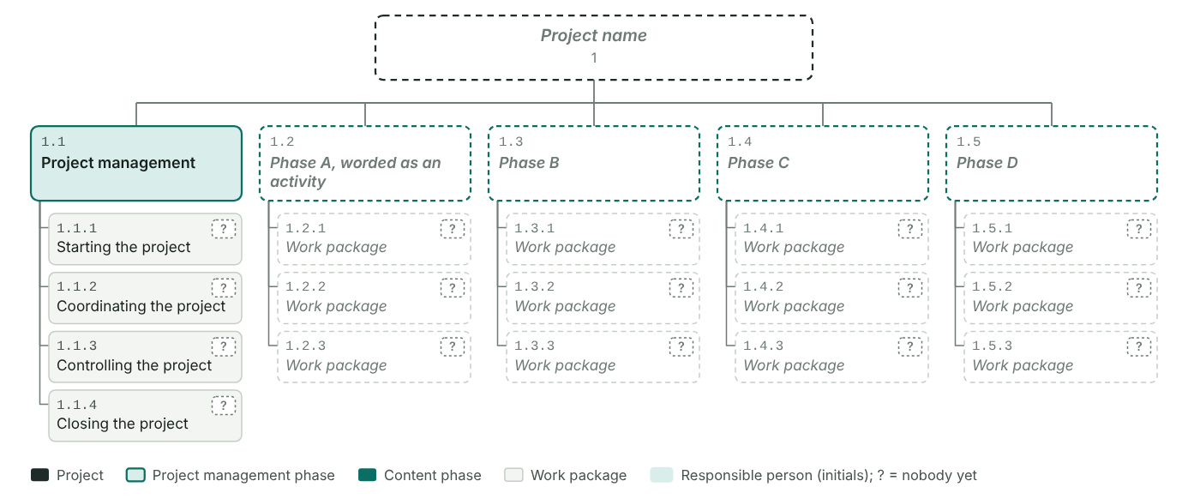
Figure 21: The project on top, the phases in one row with project management first, the work packages below each phase. Tags show who is responsible; a "?" means nobody is assigned yet. More than six phases wrap into a second row.

Work breakdown structure as a process
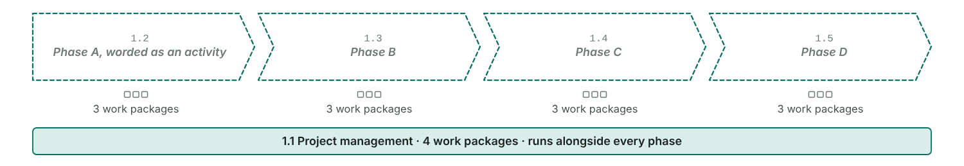
Figure 22: The content phases in process order, with one square per work package. Project management runs alongside every phase.

WBS rules
✓ At least 4 content phases plus the project management phase 1.1. Now: 4 content phases, project management phase present.
✓ Every phase has at least 3 work packages.
✗ Every work package needs exactly one responsible person. Missing for: 1.1.1, 1.1.2, 1.1.3, 1.1.4, 1.2.1, 1.2.2 and 10 more.
✓ All codes are unique and every code has its parent line.
✓ Within each phase, all work packages sit on the same level.
✗ Name work packages with a noun and a verb, like "building the hull". Found 12 lines without a name yet.
• Wording: 4 of 4 names read as tasks ("building …"), 0 as results ("… built"). Pick one style and keep it.
• No results named yet. Fill in the results plan to check the WBS for completeness.
• Work packages without a result: 1.1.1, 1.1.2, 1.1.3, 1.1.4, 1.2.1, 1.2.2 and 10 more. Add one in the WBS or link one from the results plan.
• Project management phase 1.1 covers start, coordination, controlling and closing.

3.5 Schedule: milestones and bar chart
Turn the WBS into dates: milestones first, then a phase plan and a bar chart. Estimate how long each work package takes.
Method: How to build the schedule
Inputs: the time boundaries with any fixed deadlines, the WBS, and first assumptions about who works on what.
- Pick the tools that fit the project and the people who will read the plan (table below).
- Mark the time-critical events as milestones in the WBS.
- Move them into the milestone plan.
- Estimate the duration of each work package and set start and end dates.
- Draw the high-level schedule: a phase plan with the milestones. The detailed schedule with links follows in the start process (4.2).
Method: No project without a milestone plan
- Find the time-critical events and place them as milestones in the WBS.
- Copy them into the milestone plan and word each one as an event ("… completed").
- Give each a realistic date, top-down from the deadline or bottom-up from the work packages.
- Freeze these baseline dates once the sponsor approves the project.
- During controlling, fill in the revised and actual dates.

Scheduling tools
Tool | Content | Use | Used in our project? | Who reads it
Milestone plan | Time-critical events (duration 0) with baseline, revised and actual dates | Plans the critical dates at a high level and focuses the team
Schedule list | All work packages with start and end date | Detailed dates when there are only a few work packages
Bar chart | Work packages as bars on a timeline | Makes the dates visible at a glance
Linked bar chart | Bars plus the links between predecessors and successors | Shows dependencies; lets you simulate changes
Network diagram | Work packages and dependencies as a network with earliest and latest dates | Shows float and the critical path; for complex projects

Milestones
Events with no duration that mark the start or end of a work package or phase.

Milestone plan
No. | WBS | Milestone | Type | Baseline | Revised | Actual | Shift
1 |  | Project started | Internal
2 |  |  | Internal
3 |  |  | Internal
4 |  |  | Internal
5 |  |  | Internal
6 |  | Project completed | Internal

Milestone rules
✗ Phases without a milestone: 1.1 Project management, 1.2 Phase A, worded as an activity, 1.3 Phase B, 1.4 Phase C, 1.5 Phase D. Link a milestone to the phase or one of its work packages (WBS column).
✓ All milestones are worded as events.
✗ Without a baseline date: Project started, Project completed.
• Set the project start and end dates (time boundaries) to compare the number of milestones with the controlling cycles.
• All milestones are internal. Mark the ones a customer, an authority or another outside party sees as external.

Duration estimates
Estimate per work package before you set dates.

Duration estimates per work package
WBS | Work package | Method | Optimistic | Realistic | Pessimistic | Three-point | Spread | Amount of work | Output per day | Analytical | Planned | Fixed start | Basis and assumptions
1.1.1 | Starting the project
1.1.2 | Coordinating the project
1.1.3 | Controlling the project
1.1.4 | Closing the project
1.2.1 | Work package
1.2.2 | Work package
1.2.3 | Work package
1.3.1 | Work package
1.3.2 | Work package
1.3.3 | Work package
1.4.1 | Work package
1.4.2 | Work package
1.4.3 | Work package
1.5.1 | Work package
1.5.2 | Work package
1.5.3 | Work package

Dates
Planned (baseline) and actual dates per work package.

Dates per work package
WBS | Name | Start | End | Days | Predecessors | Actual start | Actual end | Done (%)
1 | Project name
1.1 | Project management
1.1.1 | Starting the project
1.1.2 | Coordinating the project
1.1.3 | Controlling the project
1.1.4 | Closing the project
1.2 | Phase A, worded as an activity
1.2.1 | Work package
1.2.2 | Work package
1.2.3 | Work package
1.3 | Phase B
1.3.1 | Work package
1.3.2 | Work package
1.3.3 | Work package
1.4 | Phase C
1.4.1 | Work package
1.4.2 | Work package
1.4.3 | Work package
1.5 | Phase D
1.5.1 | Work package
1.5.2 | Work package
1.5.3 | Work package

3.5 Resources and costs
Plan who is needed, how many person-days and what it costs, per phase or work package. Every table and chart below comes from the one cost plan.
Method: How to plan resources and costs
Build on the WBS and the schedule, and on the experience of the people who will do the work. Plan it together with the team.
- Choose the resource types (divisions or qualifications) and the cost types you plan with.
- Decide the planning depth: per phase for a rough plan, per work package for a detailed one.
- For each phase or work package, plan the person-days per resource type and the other costs.
- Merge the lines into the staff placement table and the cost table.
- Check with the line managers that the people and the budget are available.
- Optional: spread person-days and costs over the schedule (section 4.2).
- Optional: draw the histograms and the cumulative cost curve (section 4.2).
Who is needed, with which qualification? How many person-days, and when? From where: internal or bought in? Are they available then? Staff cost = person-days × internal cost rate.
Derive the staffing from the WBS, the work package specifications and the RACI chart. Plan critical resources in detail. Make sure actual values can be measured later, for example by booking time on WBS codes.

Step 1: resource and cost types

Resource types
No. | Resource type | Unit | Cost rate (€) | Available | From | Note
1 | Project management | PD |  |  | Internal
2 |  | PD |  |  | Internal
3 |  | PD |  |  | Internal
4 | External specialist | PD |  |  | External

Project cost types
Project cost type | Accounting cost types grouped here | Plan (€)
Staff
External labour
Material or investment
Other
Total |  | € 0

Steps 2 and 3: depth and the plan per line
Planning depth

Resource and cost plan
No. | WBS | Resource or cost type | Cost type | Quantity | Unit | Cost per unit (€) | Plan (€) | Actual (€) | Remaining (€) | Forecast (€) | Deviation (€) | Note
1 |  | Project management | Staff |  | PD
2
3 |  | External labour | External labour |  | —
4 |  | Material or investment | Material or investment |  | —
5 |  | Other | Other |  | —
 | Total |  |  |  |  |  | € 0 | € 0 | € 0 | € 0 | € 0

Step 4: staff placement and cost table

Staff placement table
Built from the cost plan: person-days per WBS line and resource type. Actual and remaining are converted from money with the rate of the line.
WBS | Phase / WP | Resource type | Plan (PD) | Actual (PD) | Remaining (PD) | Forecast (PD) | Deviation (PD)

Cost table
Built from the cost plan: costs per WBS line and project cost type.
WBS | Phase / WP | Cost type | Plan (€) | Actual (€) | Remaining (€) | Forecast (€) | Deviation (€)

Step 5: availability

Checks
• Add lines with quantities or amounts to the cost plan to run the checks.
Steps 6 and 7 (spreading over time, histograms, cost curve) are in section 4.2.

3.6 Project approval
The project owner and the project manager meet face to face to authorise the planning so far. The result is the (preliminarily) released Project Charter.

Step record I5: Project approval
Status
When
Format used
Who took part
What we did
Result

Approval meeting
Date
Place
Format
Participants
Project Charter
Business case verified

Agenda of the approval meeting
☐ Authorise the current planning
☐ Decide how to go forward
☐ Verify the investment appraisal (business case)
☐ Approve the project and the further planning process
☐ Agree the PM plan draft

Approval path
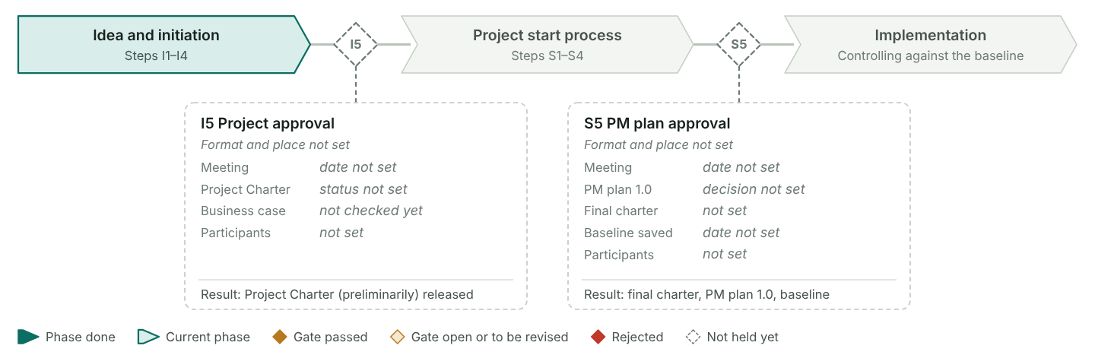
Figure 23: The two gates of the method. The project approval (I5) releases the charter, at least preliminarily, and opens the project start process. The PM plan approval (S5) confirms the final charter and the PM plan and freezes the baseline. Dates and decisions come from this section and from 4.5.

Decisions and conditions
No. | Decision | Condition or requirement | Owner | Due
1
2

Open points
No. | Open point | Owner | Due | Status
1
2
A preliminarily released charter lets the start process begin while some conditions are still open. Give each condition an owner and a date, and confirm the final charter in step S5.

4.1 Project organisation
Set up who steers, who leads and who works in the project, what each role may decide, and how the project sits in the line organisation.

Step record S1: Establish the project organisation
Status
When
Format used
Who took part
What we did
Result
Method: Principles
Plan the organisation on purpose once the charter is released.
- Start from the scope plan: bring in every unit and every kind of know-how the work packages need, internal and external.
- Everyone responsible for a work package belongs to the core team.
- Make the paths for information and decisions clear: who informs whom, who decides what.
- Settle the sub-teams, functional or interdisciplinary, and what each of them may decide.
Method: Six steps
- Draw the organisation chart.
- Describe the roles.
- Set up the communication plan (next section).
- Agree the cultural elements (next section).
- Check the organisational incorporation.
- Optional: create a RACI chart (section 4.2).

People and roles
No. | Name | Short | Project roles | Department / company | Sub-team | Contact
1 |  |  | Project owner
2 |  |  | Project manager
3 |  |  | PMTM
4 |  |  | PMTM

Sub-teams
No. | Sub-team | Type | Lead | Members | Decision power | Meets
1
2

Organisation chart
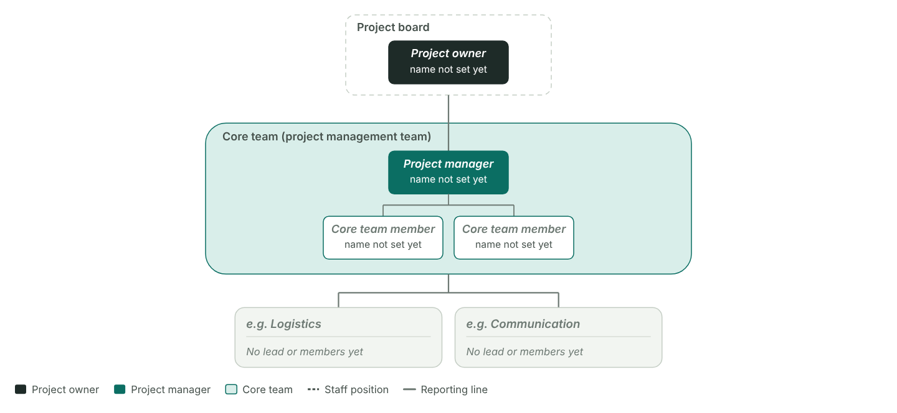
Figure 24: The board with the project owner on top, the PM and the core team in the band, staff positions beside the PM and the sub-teams below. People with a sub-team that is not in the table form their own sub-team.

Role descriptions
Each role has tasks, powers and responsibilities. Roles are independent of people; one person often holds several.

Roles
No. | Role | Kind | Tasks | Powers | Responsibilities | Held by
1 | Project owner | Individual
2 | Project manager | Individual
3 | Project management team member | Individual
4 | Project team member | Individual
5 | Project board | Group
6 | Project management team | Group
7 | Project team(s) | Group

Mutual expectations
No. | From role | To role | Expectation | Agreed
1 | Project owner | Project manager
2 | Project manager | Project owner

Mutual expectations
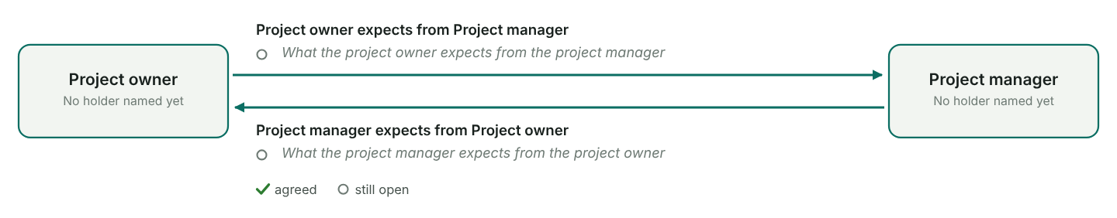
Figure 25: The pair of roles with the most expectations, facing each other. The upper list is what the left role expects, the lower list what the right role expects.

Organisational incorporation
The form of organisation settles who decides about a team member: the line manager or the PM.

Who decides?
Question | Content side | Staff side | Influence | Matrix | Pure project | Content side | Staff side
What? | Work package, content | Tasks, competencies | Line | PM | PM
When? | WP dates, deadlines | Holidays, time off | Line | PM | PM
How? | Methods, procedures | Qualifications, equipment | Line | Line | PM
How good? | Quality | Performance assessment | Line | Line | PM
How much? | Resources, costs | Salary, bonus | Line | PM | PM
Who? | Responsible person for the WP | Selection of team members | Line | Line | PM

Form of organisation
Form we use
Closest to your answers
Why this form

The three forms compared
Form | Position of the PM | Advantages | Disadvantages | Fits us?
Influence organisation | Coordinates from a staff position without authority to decide | Team members stay in their departments; continuous workload; heads of department keep control of the resources | Long decision paths; line work often comes first; low identification with the project; escalation through the line is laborious
Pure project organisation | Leads a temporary organisational unit with full authority to decide | Full concentration on the project; fast decisions; strong identification | Staff have to be released and re-integrated; continuous workload for project staff has to be ensured; people may lose touch with the home organisation
Matrix organisation | Cross-sectional function with responsibility for the whole project | Flexible use of staff; specialists are coordinated; team members stay anchored in their departments | Team members report twice; resource management is demanding; highest coordination effort of the three

Organisational incorporation
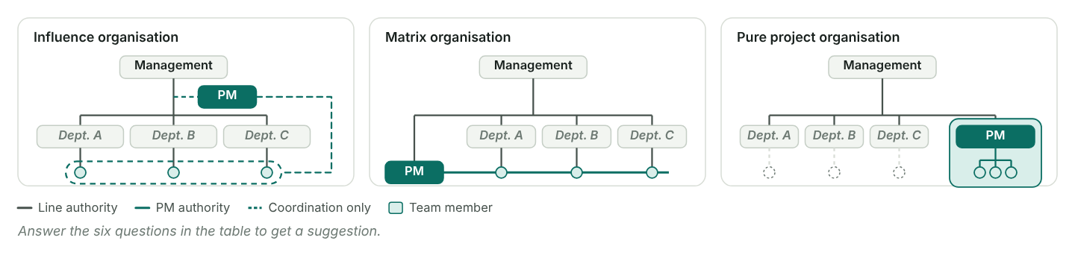
Figure 26: The line organisation with its departments and the project side by side. The large panel shows the chosen form (or the suggested one); the two small panels show the other forms for comparison. Departments come from the people list.

Checks
✗ Name the project owner and the project manager in the people list.
• Assign responsible persons to the work packages to check the core team.
✗ Roles without a holder: Project owner, Project manager, Project management team member, Project team member, Project board, Project management team, Project team(s).

4.1 Communication, culture and team development
Plan the regular meetings, agree the culture of the project and follow how the team grows together.
Method: Communication plan
- Set clear paths for information and decisions, and cover the regular needs, including information for stakeholders.
- Keep content meetings apart from project management meetings.
- Choose the form by purpose: one-to-one talk, meeting, workshop or presentation.
- Give every regular meeting a chair, a rhythm and someone who writes the minutes.

Communication plan
No. | Meeting | Objectives and content | Participants | Chair | Rhythm | First date | Place | Form | Kind | Minutes by
1 | Project board meeting | Present progress; discuss deviations with causes and measures; take the decisions the controlling meeting asks for; approve the progress report | PO, PM, board members |  | Every 4 weeks |  |  | Meeting | Project management
2 | Project controlling meeting | Project status; controlling of scope, dates, resources and costs; stakeholder relations and risks; overarching problems; prepare decisions for the board; next steps | PM, core team members |  | Every 4 weeks |  |  | Meeting | Project management
3 | Sub-team meeting | Coordinate the sub-team; discuss content topics and the decisions they need; plan next steps | Sub-team |  | As required |  |  | Meeting | Content
4 | Project start workshop | Work out planning and organisation together; agree roles, meetings and ground rules | PM, core team, team members |  | Once |  |  | Workshop | Project management
5 | Kick-off meeting | Present the results so far and brief the whole team | PO, PM, core team, team members |  | Once |  |  | Presentation | Project management

Project culture
Every project has its own culture, which can differ from the company's. Name, logo, slogan, roles, ground rules, rituals and the style of management give it an identity.

Identity
Project name
Slogan
Logo
Style of management and communication

Ground rules
No. | Rule | Why | Agreed on
1 | No deputies
2 | Minutes are binding
3 | E-mail is the primary channel
4 | Phones off in meetings
5 | We give and receive feedback

Rituals and social events
No. | What | When | Who
1
2

Team development
Teams go through five phases. Watch for the signs and steer: give orientation early, settle conflicts, delegate once the norms hold, close with a joint review.

Team phases
Phase | Typical signs | When | What we noticed | What the PM did
Forming | Polite, careful, insecure
Storming | Conflicts, unclear roles, slow progress
Norming | Ground rules, roles settle, feedback
Performing | Efficient, flexible, mutual support
Adjourning | Joint review, taking in what was learned

Team development
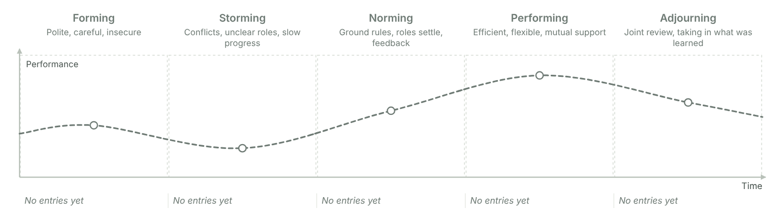
Figure 27: Performance over time through the five phases, with the dip in storming. Under each phase: when it happened and what the PM did. Phases without entries are drawn muted.

Checks
✓ The plan has a board meeting.
✓ The plan has a controlling meeting.
✓ Content and project management meetings are kept apart.
✗ Chair or minute-taker missing: Project board meeting, Project controlling meeting.
✗ 5 ground rule(s) not agreed with the team yet.

4.2 Who does what: RACI chart
Decide for every work package who leads it, who works on it, who approves it and who is kept informed.

Step record S2: Detailed planning
Status
When
Format used
Who took part
What we did
Result
Method: Three ways to record who does what
Pick the level of detail the project needs. Each way adds to the one before.
- A list with the responsible person for each work package.
- Names or initials written into the WBS or the bar chart.
- A RACI chart: work packages as rows, people or roles as columns, a letter in each cell where someone is involved.
Method: The four letters
R and C are always used. A and I are optional; add them when approvals or reporting lines need to be clear.
- R, responsible: leads the work package and delivers its result. Exactly one per work package.
- C, contributes: works on the package and supplies part of the result.
- A, accountable: approves the result, often the project owner.
- I, informed: hears about progress and results, without working on them.
The chart makes responsibilities explicit, gives target agreements a base, shows every person the number and kind of their tasks, and helps in conflicts and when planning staff.
Make a first version now and complete it once the work package specifications are written. The specifications show who really has to contribute.

Columns
People shown as columns | All people

RACI chart
WBS | Work package | PO | PM | PMTM 1 | PMTM 2 | People
1.1.1 | Starting the project
1.1.2 | Coordinating the project
1.1.3 | Controlling the project
1.1.4 | Closing the project
1.2.1 | Work package
1.2.2 | Work package
1.2.3 | Work package
1.3.1 | Work package
1.3.2 | Work package
1.3.3 | Work package
1.4.1 | Work package
1.4.2 | Work package
1.4.3 | Work package
1.5.1 | Work package
1.5.2 | Work package
1.5.3 | Work package

Checks
• Put R, C, A or I into the chart to run the checks.

RACI matrix
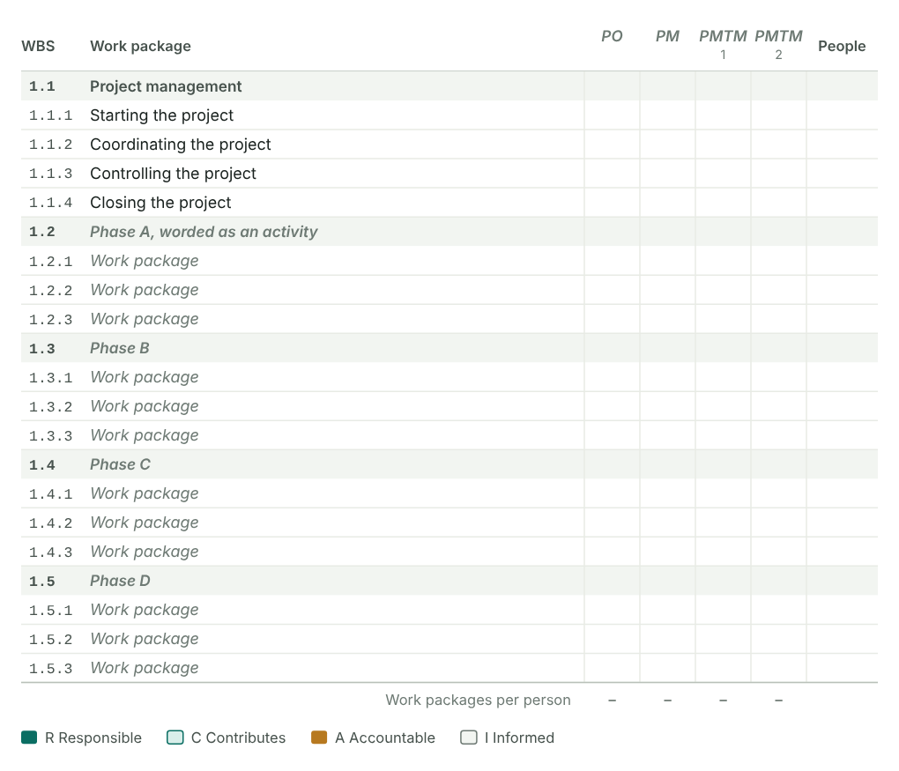
Figure 28: The chart as a picture for the PM plan, grouped by phase. The last column counts the people per work package, the last row the work packages per person. A red code marks a row without an R or with more than one.

4.2 Work package specifications
Describe the larger or riskier work packages in a short, agreed form, so that the responsible person and the PM mean the same thing.
Method: What a specification is for
It gives the PM and the work package owner the same picture, avoids duplicated work and idle time, makes schedule, staff and cost estimates more reliable and makes progress measurable.
- Settle who is responsible for each work package (RACI chart) and choose the work packages that need a specification.
- Agree a template if the one below does not fit.
- Define the specifications together with the whole team.
- Each responsible person works out the specification for their work package.
- Agree the specifications in the team, across all disciplines.
- Adapt, detail or extend the schedule, staff and cost plans where needed.
Split a long work package into a few visible steps and give each the share of work done when it is reached, for example "offers in = 25%". Progress is then counted, not guessed.

Which work packages need a specification
WBS | Work package | Responsible | Needs a specification | Status | Note
1.1.1 | Starting the project
1.1.2 | Coordinating the project
1.1.3 | Controlling the project
1.1.4 | Closing the project
1.2.1 | Work package
1.2.2 | Work package
1.2.3 | Work package
1.3.1 | Work package
1.3.2 | Work package
1.3.3 | Work package
1.4.1 | Work package
1.4.2 | Work package
1.4.3 | Work package
1.5.1 | Work package
1.5.2 | Work package
1.5.3 | Work package

Work package specification (form)
WBS code and name
Responsible
Content
Non-content
Results
Measuring progress
Duration
Resources
Predecessors
Notes

Checks
• Mark the work packages that need a specification in the column "Needs a specification".

4.2 Detailed schedule: linked bar chart and network
Link the work packages, find the critical path and see how much float each one has.
Method: From bar chart to linked bar chart
The schedule is finalised from the WP specifications. Network analysis is the most demanding method; use it for complex projects.
- Give every work package a duration and name what it depends on.
- Draw the bars with their links.
- Calculate forwards and backwards: earliest and latest dates and the float. The chain without float is the critical path.
- Check the result against the resource plan and fixed dates, and optimise.
Method: Accuracy grows step by step
- Rough: phases and milestones (initiation, 3.5).
- Detailed: work packages with dates and the main dependencies.
- Verified detailed: based on the WP specifications and the resource plan.
Give each reader the level they need: the sponsor the milestone plan, the core team the phase plan, work package owners the detailed bars. A detailed bar chart is rarely useful in a controlling meeting.

Types of dependency
Type | Name | Meaning | Write it as | Example | Used
FS | Finish-to-start | B can start when A has ended | 1.2.1 or 1.2.1 FS+5 | Set-up starts once the catering contract is signed
SS | Start-to-start | B can start when A has started | 1.2.1 SS+10 | Registrations open 10 days after the invitation design starts
FF | Finish-to-finish | B can end when A has ended | 1.2.1 FF | Testing ends when development ends
SF | Start-to-finish | B can end when A has started | 1.2.1 SF | The old system runs until the new one starts
Type the predecessors in the table below: "1.2.1" is finish-to-start, "1.3.2 SS" start-to-start, "1.4.1 FS+5" finish-to-start with 5 days lag, "1.4.1 SS-2" starts 2 days before. Separate several with a comma or semicolon. A phase code such as "1.3" stands for all its work packages.

Dates and predecessors
WBS | Name | Start | End | Days | Predecessors | Actual start | Actual end | Done (%)
1 | Project name
1.1 | Project management
1.1.1 | Starting the project
1.1.2 | Coordinating the project
1.1.3 | Controlling the project
1.1.4 | Closing the project
1.2 | Phase A, worded as an activity
1.2.1 | Work package
1.2.2 | Work package
1.2.3 | Work package
1.3 | Phase B
1.3.1 | Work package
1.3.2 | Work package
1.3.3 | Work package
1.4 | Phase C
1.4.1 | Work package
1.4.2 | Work package
1.4.3 | Work package
1.5 | Phase D
1.5.1 | Work package
1.5.2 | Work package
1.5.3 | Work package

Network settings
Left out of the network

Critical path
Calculated from the durations and predecessors. Day 0 is the project start.

Earliest and latest dates per work package
WBS | Work package | Responsible | Duration from | Duration | ES | EF | LS | LF | TF | FF | Critical | Earliest start | Latest finish | Planned start
1.1.1 | Starting the project |  | Missing
1.1.2 | Coordinating the project |  | Missing
1.1.3 | Controlling the project |  | Missing
1.1.4 | Closing the project |  | Missing
1.2.1 | Work package |  | Missing
1.2.2 | Work package |  | Missing
1.2.3 | Work package |  | Missing
1.3.1 | Work package |  | Missing
1.3.2 | Work package |  | Missing
1.3.3 | Work package |  | Missing
1.4.1 | Work package |  | Missing
1.4.2 | Work package |  | Missing
1.4.3 | Work package |  | Missing
1.5.1 | Work package |  | Missing
1.5.2 | Work package |  | Missing
1.5.3 | Work package |  | Missing

Network checks
✓ All predecessor codes exist in the WBS.
✓ No loops in the dependencies.
✗ No dates and no estimate, so not in the calculation: 1.1.1, 1.1.2, 1.1.3, 1.1.4, 1.2.1, 1.2.2 and 10 more.

4.2 Detailed resources and costs: over time
The cost plan of section 3.5 at work package level, spread over the months of the schedule: staff per month, costs per month, the cost curve and the payments.
Method: Resources and costs at work package level
- Staff allocation plan: person-days per work package for each resource type or department.
- Cost plan: cost per work package for each project cost type. The many accounting cost types are grouped into four: staff, external labour, material or investment, other.
- Spread both over the schedule: each line evenly over the calendar days of its work package.
- The resource histogram shows the peaks; check them against what the departments can give.
- The cumulative cost curve has an S shape. It is the cost baseline you control against.
- Set the incoming payments against it to see when costs run ahead of payments. Total billed minus the budget is the gross margin.
- Use the comparison to agree payment plans and as the basis for earned value analysis.

Staff over time

Staff required per month
Planned person-days per resource type and month. Each line is spread evenly over the calendar days of its WBS line.
Resource type | Total

Costs over time

Costs per month
Planned costs per project cost type and month (€, rounded).
Cost type | Total

Payments and gross margin

Incoming payments
No. | Date | Description | Amount (€) | Received
1
2
 | Total |  | € 0

Total billed
Gross margin

Checks
• Add lines to the cost plan (section 3.5) to run the checks.

4.3 Consolidate and coordinate the detailed planning
The plans from the detailed planning are brought together, checked against each other and agreed by the team. Afterwards everyone works from the same validated plans.

Step record S3: Consolidate and coordinate
Status
When
Format used
Who took part
What we did
Result
Method: How the plans come together
- Team members prepare their plans alone or in pairs.
- In a face-to-face follow-up workshop the team puts the plans side by side: dates, staff, costs and risks must fit each other.
- Change what does not fit and mark each plan as validated.
- Set up project marketing so the project is visible to the people it affects.
- Complex projects may need several planning cycles.

Follow-up workshop
Date
Place
Planning cycles
Participants

Plan check
Plan | Status | What changed | By | Section
Linked bar chart / schedule
Staff deployment (resource plan)
Cost plan
Risk analysis
RACI chart
WP specifications
Communication plan
Project marketing

Consolidation status
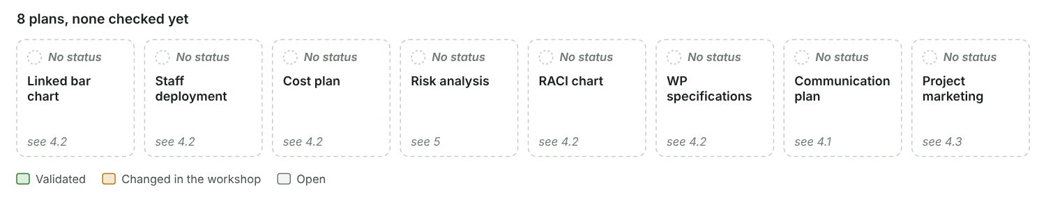
Figure 29: The eight plans at a glance. Green plans are validated, amber plans were changed in the workshop, grey plans are still open. The note shows what changed.

Project marketing
Make the project known to the people it affects, so they support it and are not surprised by it.

Project marketing plan
No. | Measure | Target group | Channel | When | Responsible | Status
1
2
3

4.4 Finalise the PM plan
The PM plan collects every plan of the project in one place. Send it to all core team members and settle the last open points before it goes to the project owner.

Step record S4: Finalise the PM plan
Status
When
Format used
Who took part
What we did
Result
Method: What the PM plan does
- Shows the current status of the project at any time.
- Keeps all project management instruments together and consistent.
- Records the project history, which helps when the project manager changes.
- Lets the organisation learn from the project.

Finalising
Sent to all PMTMs on
Last internal meeting on open points
Where the PM plan is stored

Contents of the PM plan
Section | Document | Included | Version | File or location | Owner | Status
3.3 | Project Charter
3.4 | Stakeholder analysis
3.5 | Results plan
3.5 | Work breakdown structure (WBS)
4.2 | WP specifications
3.5 | Milestone plan
3.5, 4.2 | Bar chart / schedule
4.2 | Network analysis
3.5, 4.2 | Resource plan
3.5, 4.2 | Cost plan
4.1 | Organisation chart
4.1 | Role descriptions
4.1 | Communication plan
4.1 | Ground rules and project culture
4.2 | RACI chart
5 | Risk table
7 | Change request process
4.3 | Project marketing plan
8 | Situational analysis and method check

Version history
No. | Version | Date | What changed | Author | Sent to
1
2

Filing structure
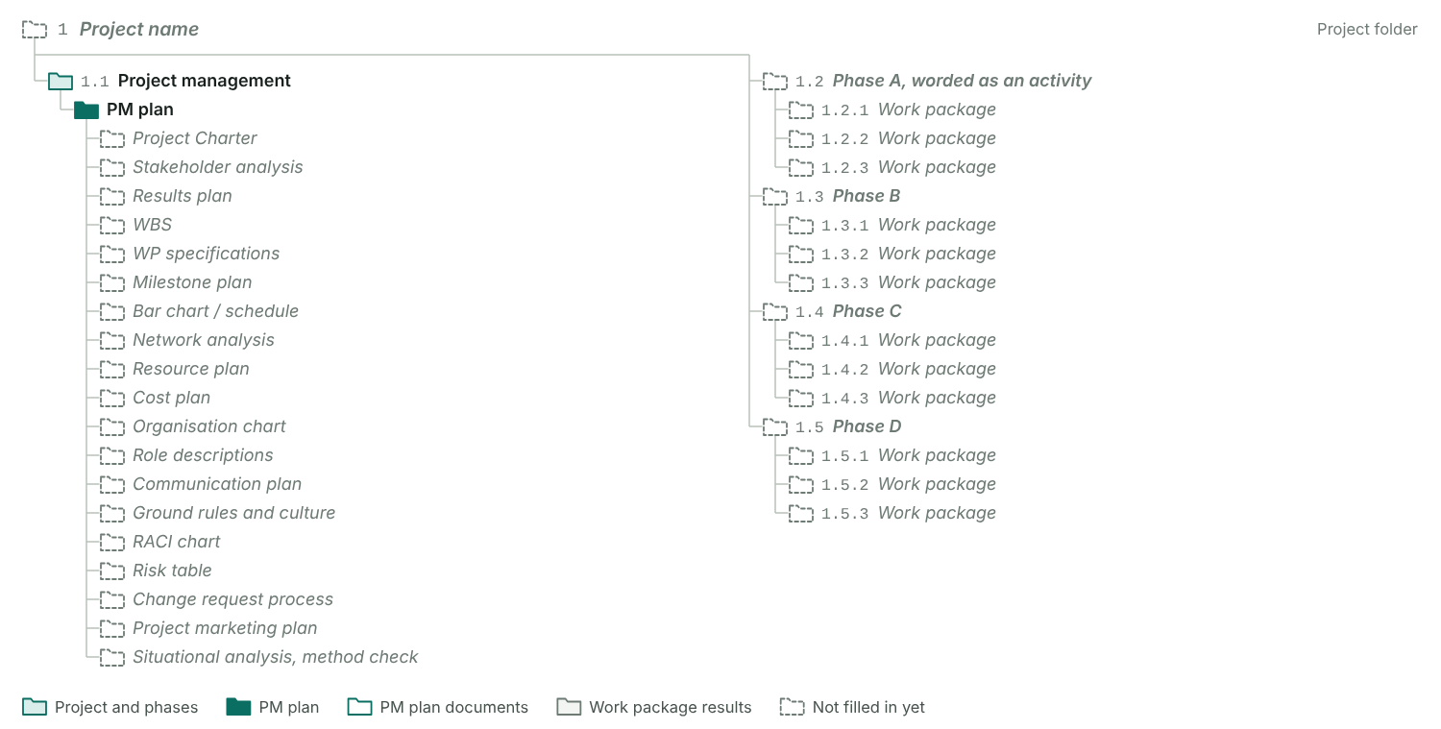
Figure 30: The WBS doubles as the filing structure. The project management phase holds the PM plan with one folder per included document; every other phase holds one folder per work package for its results.

4.5 Approve the PM plan
The project manager presents the planning to the project owner or the steering committee. Their approval of the final charter and the PM plan 1.0 ends the project start process.

Step record S5: Approve the PM plan
Status
When
Format used
Who took part
What we did
Result

Approval meeting
Date
Format
Decision
Participants
Final charter approved
Approved PM plan version
Baseline saved on

Agreed in the meeting
☐ Roles agreed
☐ Communication structures agreed
☐ Reporting rhythm agreed
☐ How changes are handled (change request process) agreed
☐ Baseline saved

Baseline
Baseline | Frozen on | Version | Where stored | Note
Milestone baseline
Schedule baseline
Cost baseline (S-curve)
Scope baseline (WBS)
Risk budget
Project controlling compares every later status with the baseline: milestones, dates, costs, scope and the risk budget.

Approval checks
• Record the decision on the PM plan.
• Record whether the final charter was approved.
• Save the baseline on the day of approval.
• 0 of 5 agreements ticked

5 Risk management
Find the risks, put a value on them and decide what you do about them. The risk values add up to the risk budget the sponsor approves.
Method: Risk management in four steps
The team does this together and repeats it throughout the project. It builds on the plans and can change them. Some risks will always stay unidentified.
- Identify: collect risks from the project plans, checklists, content documents, expert interviews, brainstorming and lessons learned. Look at content and quality, dates, and resources and costs.
- Assess: estimate what the risk would cost if it happens and how likely it is, usually between 5% and 70%. Risk value = risk cost × probability. Work on the highest values first.
- Plan measures: preventive measures act now, corrective measures are ready for when the risk occurs. Pick a strategy for each risk: avoid, reduce, transfer or accept.
- Implement and control: put the preventive measures into the WBS and the cost plan. Review the risks regularly, reassess them, add new ones, trigger corrective measures and record the changes.

Risk management in four steps
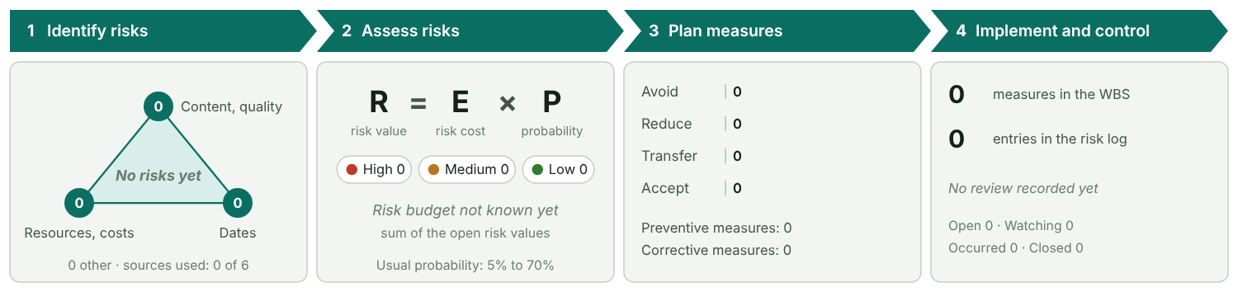
Figure 31: Filled from the risk table and the risk log. Corners of the triangle: risks on content and quality, resources and costs, and dates.

Terms
Term | Meaning | In our project
Risk | A single future event that may affect content and quality, dates, resources or costs. The effect can be negative or positive.
Crisis | An event that threatens the project as a whole. It goes to the sponsor at once.
Risk management | Finding and assessing risks, planning measures, carrying them out and checking them.

Identify and assess
Steps 1 and 2
Sources used
First risk assessment
Full risk analysis

Priority thresholds
High from
Medium from

Risk table
No. | Title | Description and cause | Category | Risk cost (€) | Delay | Probability (%) | Risk value (€) | Priority | Strategy | Preventive measure | WBS of the measure | Cost of prevention (€) | Corrective measure | Owner | Status | Positive
1
2
3
 | Total |  |  |  |  |  |  |  |  |  |  | € 0

Totals
Risk budget
Risk value of all risks
Cost of prevention
High risks not closed

Risk matrix
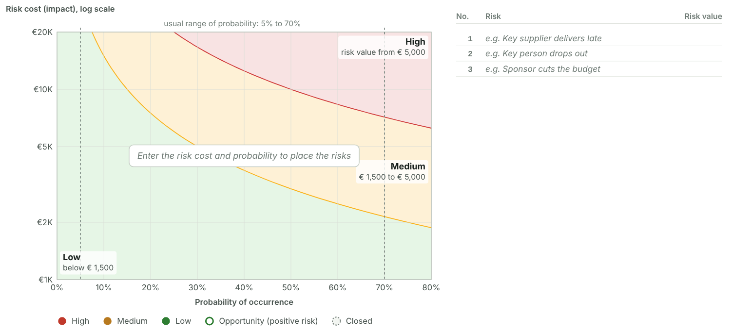
Figure 32: Each dot is one risk, numbered as in the table. The curved lines are the thresholds: along each line the risk value is the same. Dots that would cover each other are moved aside, with a thin line to their exact spot.

Risk budget and reserves
Risk budget approved by the sponsor
Approved on
Time reserve
Risk budget in the cost plan

Risk controlling
Step 4

Risk log
Date | Risk | What changed | New probability (%) | New risk cost (€) | Measure triggered | By
Involve as many people as you can, also outside the core team. Build the first risk table on a flip chart. Keep the list to the critical risks you can influence. Use your company’s standard risk table if there is one.

Checks
• Add risks to the risk table to run the checks.

6 Kick-off and start workshop
Choose how the team plans together in the start phase, then prepare the kick-off and the start workshop.
Method: Four formats you can combine
Effort and planning quality both rise from the first format to the last. Most projects combine several of them.
- Planning alone: the PM drafts plans at the desk. Quick, but the plan rests on one view.
- One-to-one meetings: the PM works through single topics with the people who know them.
- Kick-off meeting: the PM presents the results so far and briefs the team. Information flows one way.
- Project start workshop: the team works out planning and organisation together. It costs the most effort and gives the best plans and the strongest commitment.

Kick-off meeting and start workshop compared
Aspect | Kick-off meeting | Project start workshop | In our project
Purpose | Present results and brief the team with filtered information | Work out planning and organisation together
Communication | One way: talk and presentation | Team work; the PM works as part of the project management team
Effect | Information | Acceptance, motivation and commitment
Effort | Medium | High: preparation, follow-up and coordination
Planning quality | Usually low | Usually high
Duration | 2 to 4 hours | Half a day to 2 days

Formats used in this project
Format | Used | When | Participants | Note
Planning alone
One-to-one meetings
Kick-off meeting
Project start workshop
Follow-up workshop

Formats: effort and planning quality
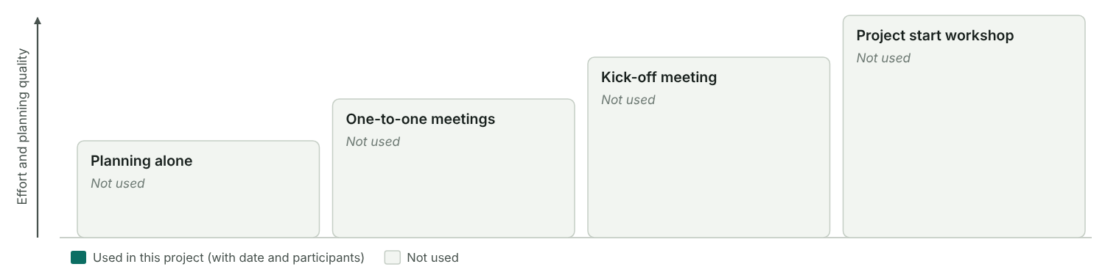
Figure 33: The four formats as steps. Each step up costs more effort and gives better plans. Filled steps are the ones this project used.

Kick-off meeting
A short meeting to inform everyone: what the project is, what has been decided, who does what.

Kick-off
Date
Duration
Place
Participants

Kick-off agenda
No. | Time | Topic | Presenter | Material
1
2
3
4
5

Project start workshop
The PM is responsible. Decide what you prepare and present, and what the team works out on the day.

Start workshop
Date
Duration
Place
External location
Moderation
Social event
Participants

Start workshop agenda
No. | Time | Topic | Method | Result | Responsible | Prepared or worked out
1
2
3
4
5
6
7

Start workshop checks
✗ Enter the participants (3 to 15 work well)
✗ Held at an external location, away from daily business
✗ The agenda mixes prepared items (0) with items worked out together (0)
• Consider a social event, such as a dinner after the workshop
• The start workshop also counts as a quality measure: the whole team checks the plan.

7 Contract management in customer projects
In a customer project the contract process runs next to the project management process. Keep the two in step.
Set the kind of project on the overview page. For an internal project this page can stay empty.
Method: Two processes side by side
Sales runs the contract process, the PM runs the project. Plan the points where they meet. What makes it hard:
- The project rests on a legal contract that is hard to change.
- The people usually change between the offer and the implementation, so information gets lost when the contract is signed.
- The interests of the parties can contradict each other.
- A valid offer already needs some project planning.
- Contract and project documents repeat each other, for example the description of services.

Contract process in this project
Step | Activities | Roles | Results | When | Who in our project | Status | Note
Acquisition | Evaluate customer expectations, check technical and commercial feasibility, plan the offer process | Sales | Rough business case, first risk assessment, customer requirements, plan for the offer
Preparation of offer | Plan the offer in detail where needed, prepare its contractual, commercial and content parts, assess risks, get approval | Sales, department | Offer documents, business case and project plans, negotiation strategy
Contract negotiation | Hand the offer to the customer, take in feedback, appoint the negotiation team, negotiate and sign | Sales, department | Adapted offer, signed contract
Project handover | Appoint PM and project team, brief the project organisation, release the offer team | Sales, department, PM | Project organisation in place, project assignment, offer team released
Contract analysis and detailed planning | Analyse the obligations of both parties, find risks and open points, plan the project | PM, PMTMs | Implementation plan, risk analysis, claim and change request strategy

Contract and project process
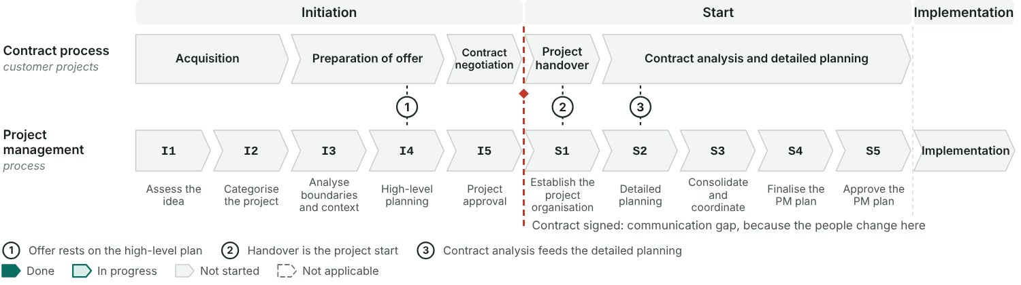
Figure 34: The contract process above, the ten steps of the project below. The numbered points are where both must be in step. The red line marks the signature, where the offer team hands over to the project team.

Contract analysis
After the handover, go through the contract and list what each party has to do, by when, and what is still open.

Obligations from the contract
No. | Obligation | Party | Clause | Due | Risk or open point | WBS
1
2

Strategies
Claim strategy
Change request strategy

Change request log
No. | Date | Requested by | Description | Scope impact | Schedule impact | Cost impact (€) | Decision | Decided by | Date decided
1
 | Total |  |  |  |  | € 0

8 Tailoring the planning process
Fit the planning process to the project: analyse the situation, choose the methods and line up the steps.
Method: The planning process is a small project of its own
Delimit it like a project: by its start and end events, its content, the people involved, its context and how it relates to your company standard. The PM is responsible and makes it transparent to everyone:
- which steps belong to the initiation and which to the project start,
- which communication formats are used,
- which methods are used, and how deep.

Boundaries of the planning process
Start event
End event
Participants
Context
Relation to the company standard

Situation analysis
Rate the project on each criterion. The profile shows what the planning process has to cover and who is needed when.

Situation analysis
Group | Criterion | Rating | Note
Planning situation | Clarity of order or contract
Planning situation | General planning situation
Planning situation | Budget situation
Planning situation | Deadline situation
Project features | Room for manoeuvre
Project features | Probable need for changes
Project features | Level of innovation
Project features | Technique or content
Project organisation | Internal participants
Project organisation | External participants
Project organisation | Location of the team
Project organisation | Content experience of the team
Project organisation | PM experience of the team
Environment | Relation to stakeholders
Environment | Relation to the customer

Result
Critical answers
Overall profile

Situation analysis profile
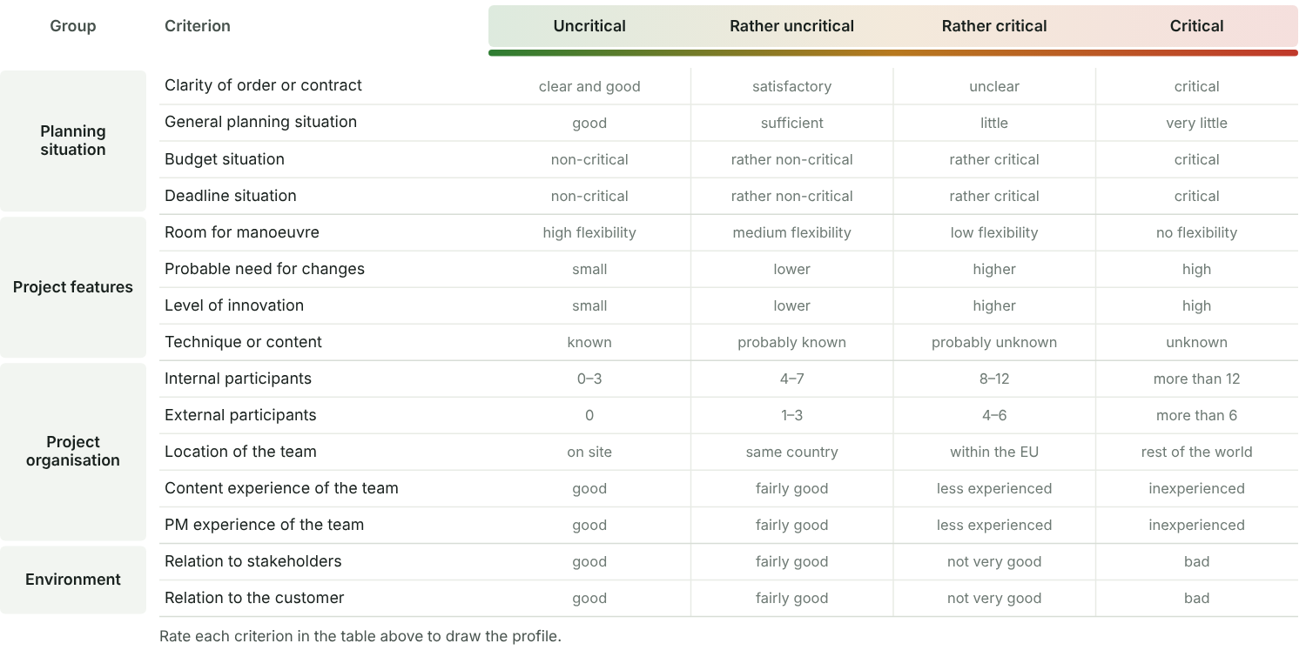
Figure 35: One row per criterion, from uncritical on the left to critical on the right. The chosen answers are joined into a profile line; the further right it runs, the more care the planning needs.
What the profile means for the planning process

Method check
For every method, decide whether it already exists, is prepared in the initiation or in the start process, or is not needed. The list is also the content of the PM plan.

Method check
Method or document | Level | Usual timing | Section | Decision | Depth | Note
Project assignment (charter) | Foundation | Initiation, finalised in the start process | 3.3
Stakeholder analysis | Foundation | Initiation | 3.4
List of deliverables, results plan | Compulsory (base camp) | Initiation | 3.5
Work breakdown structure | Compulsory (base camp) | Initiation | 3.5
Milestone plan | Compulsory (base camp) | Initiation | 3.5
Resource plan | Compulsory (base camp) | Initiation, detailed in the start process | 3.5, 4.2
Cost plan | Compulsory (base camp) | Initiation, detailed in the start process | 3.5, 4.2
Organisation chart | Organisation | Start process | 4.1
Definition of roles | Organisation | Start process | 4.1
Communication plan | Organisation | Start process | 4.1
Ground rules | Organisation | Start process | 4.1
RACI chart | Organisation | Start process | 4.2
WP specification | Optional (detailed) | Start process | 4.2
Linked bar chart or network plan | Optional (detailed) | Start process | 4.2
Risk analysis, qualitative or quantitative | All levels, grows with complexity | First assessment in initiation, full analysis in the start process | 5
Contract analysis | External projects | After the project handover | 7
Change request process | Additional | Start process | 7
Project marketing | Additional | Start process

Method pyramid
Figure 36: The more complex the project, the further up the pyramid the planning goes. Risk management runs up the side because it grows with complexity. Each method is styled by its decision in the method check.

Tailoring checks
✗ Start and end event of the planning process defined
✗ 0 of 15 situation criteria rated
✗ 0 of 18 methods decided
✓ No foundation or base camp method is skipped
• Contract analysis is only needed for customer projects.

Planning navigator
A project runs on five process levels that shift against each other. The navigator lines them up.
Method: Four steps to your navigator
- Take the generic project management process: initiation, then start.
- Define the planning and communication steps and assign them to it.
- Define the content phases of the project.
- Assign deliverables and project management methods to the steps.

Navigator of this project
Process | Planning and communication steps | Content phases covered | Deliverables | PM methods
Initiation
Start

Planning navigator
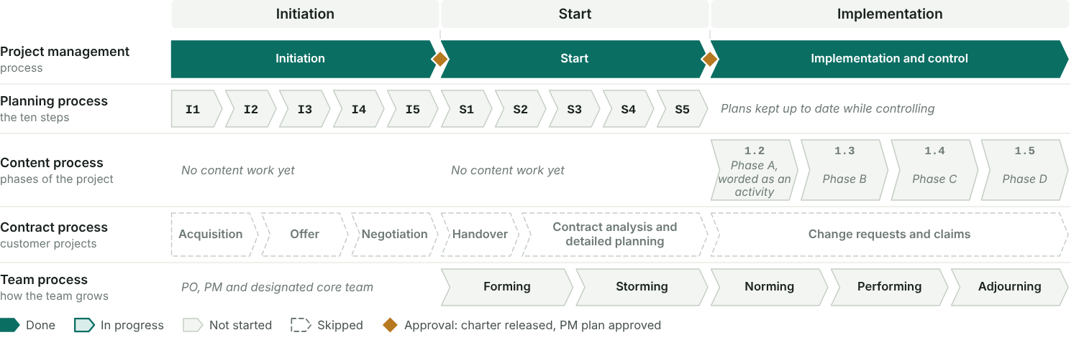
Figure 37: Five process levels under one header. Positions are relative, not dates. The planning steps take their colours from the step records; the content phases come from the WBS and the table above.

Large external or small internal project
Aspect | Large external project | Small internal project | Our project
Initiation | Assess the idea, categorise, boundaries and context, rough and detailed planning, consolidate and compile the PM plan, approval | Assess the idea or task, boundaries and context
Start | Kick-off, establish the organisation | Establish the organisation, project planning, PM plan, approval of the PM plan
Content phases | Rough and detailed concept, implementation, test, training, piloting, launch | Analysis, rough and detailed concept, implementation, training
Deliverables in initiation | Contract, project assignment, requirements, functional specification, PM plan, risks | Preliminary project assignment
Deliverables in start | Communication structures, ground rules, change request process | Final project assignment, PM plan, project organisation

Our project is closer to

